CUSTOMER

* First, you need to go to the homepage of FoodGalore Food Hub and then click on account button at the navigation bar.



* To register you will need to fill the form. Your password must contain one capital letter, small letter, one numeric key and one special character. The email address must not be repeated. After filling the form click on signup button.

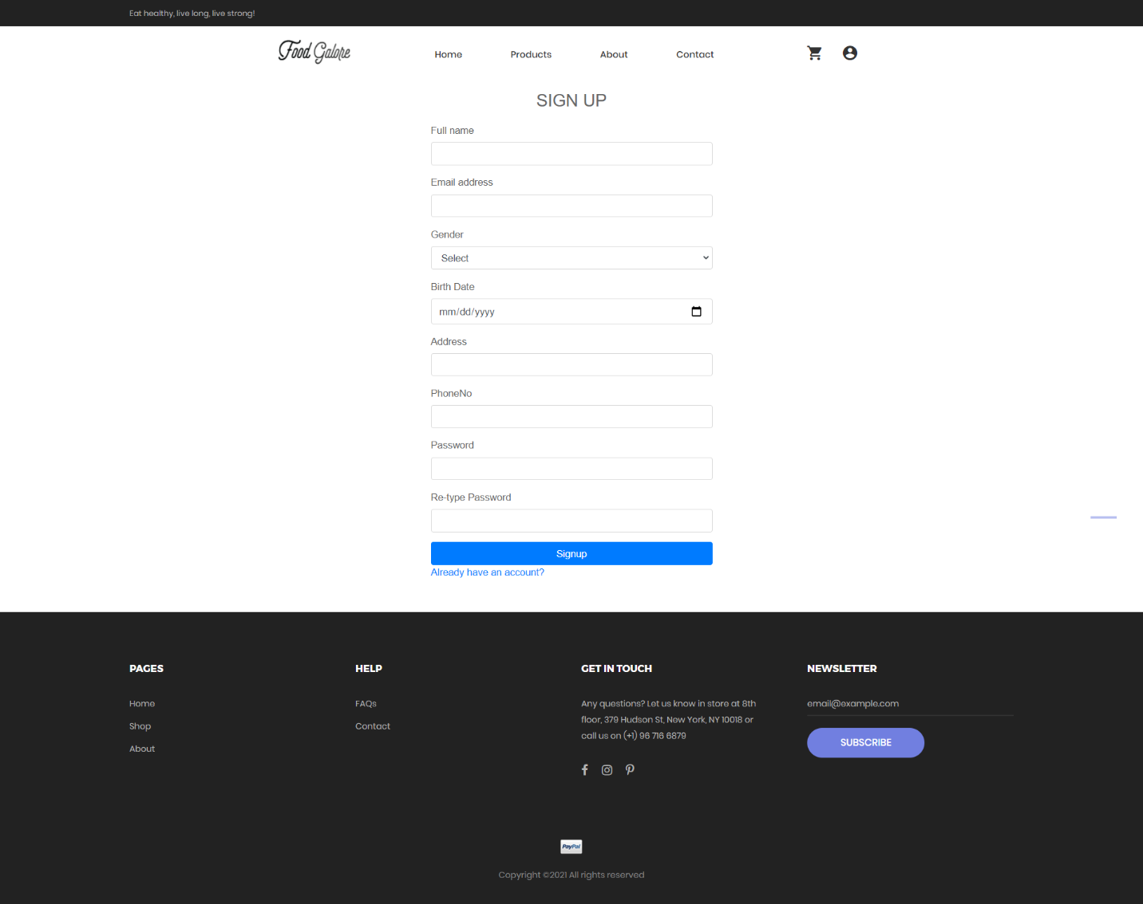

* Then, login form is displayed. You can login with valid credentials.

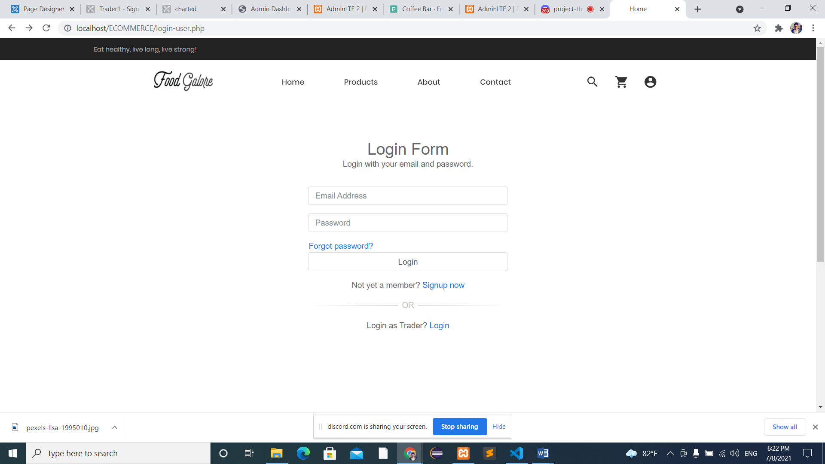

* After filling in the fields with valid information you’ll receive an OTP in your email for verification.

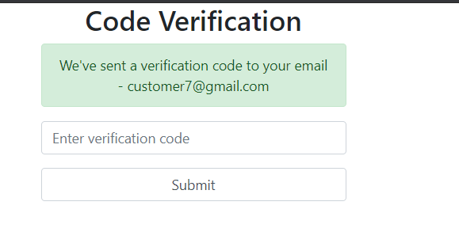

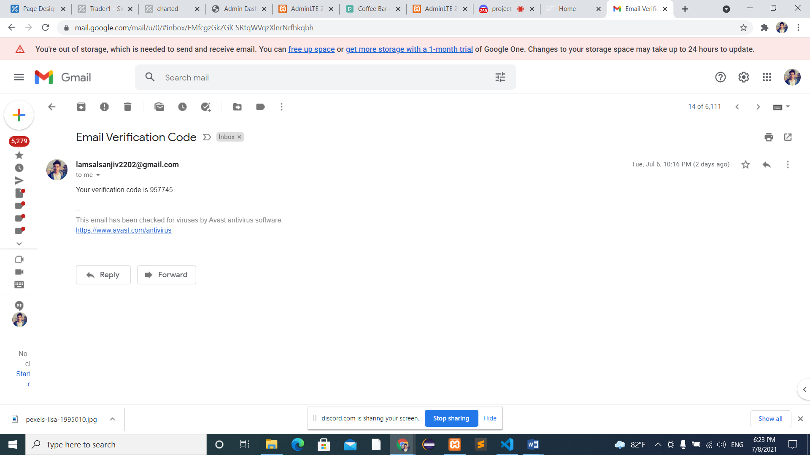

* If you forget your password, then click on forgot password and reset your password.



* After logging in you will be redirected to home page of the website.

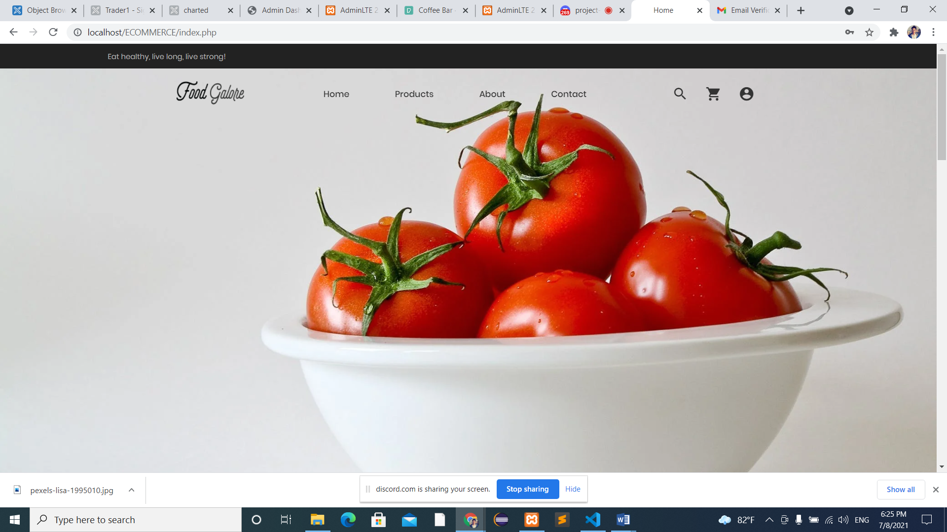

* You can also view About Us page, which will look like this.

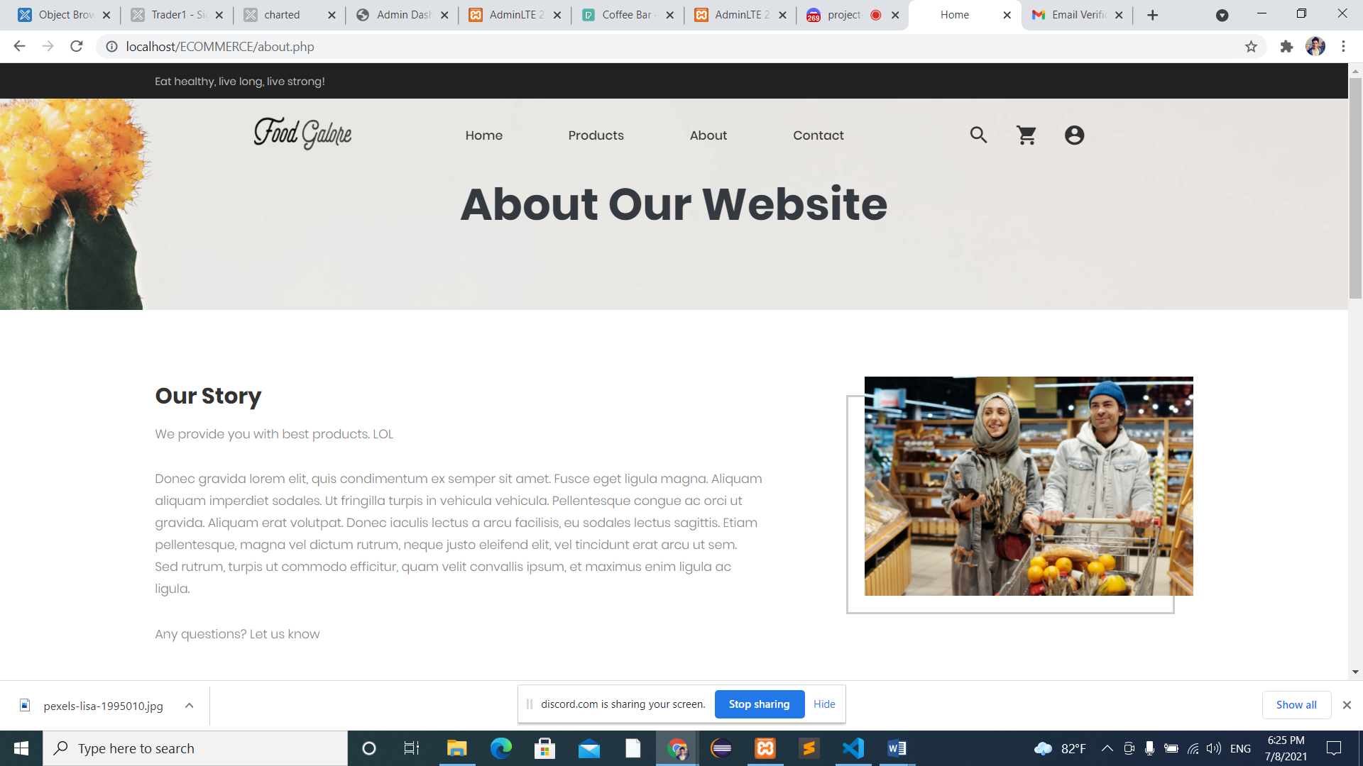

* You can see 5 shops i.e. Butcher, Greengrocer, Fish Monger, Bakery and Delicatessen.

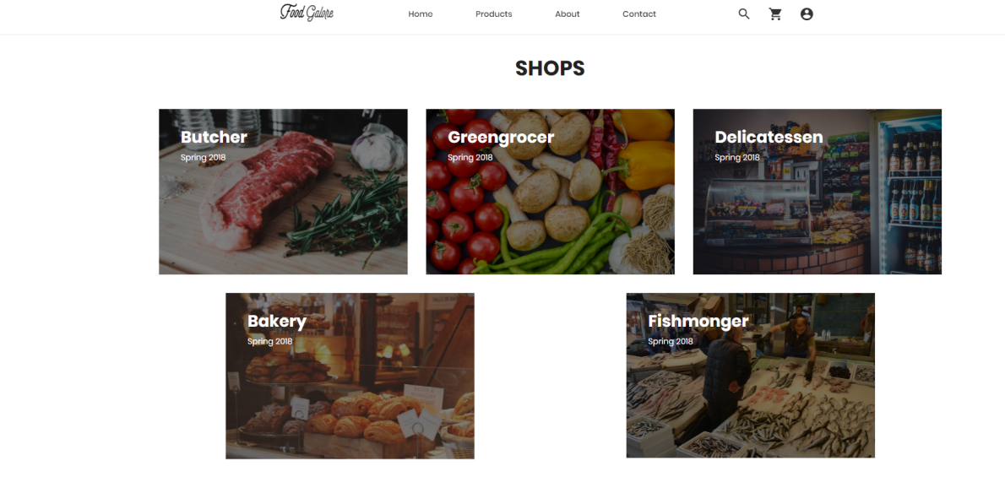

* Then you can shop the products.

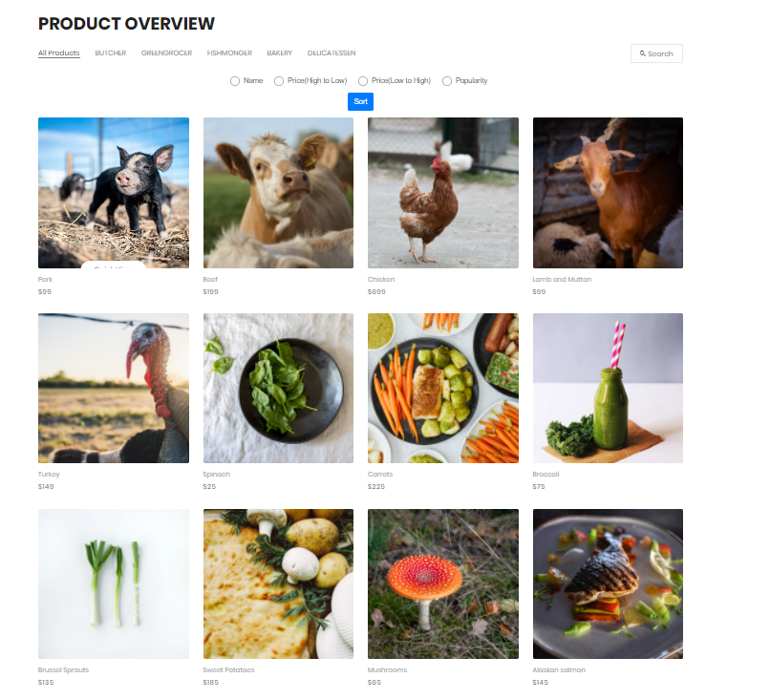

* If you want to search for a specific product then you can type in the search field, select a category and then press search.

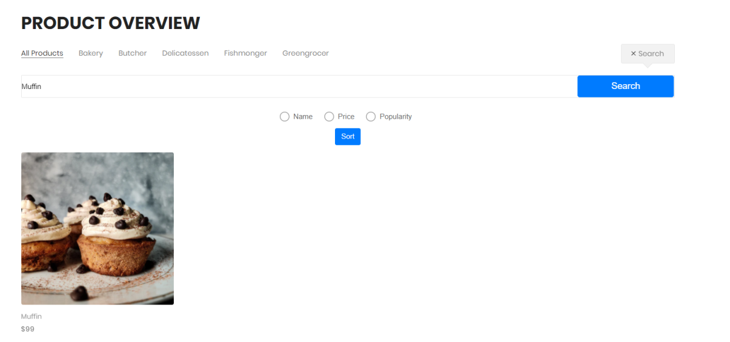

* You can also sort the product through name, price and popularity.

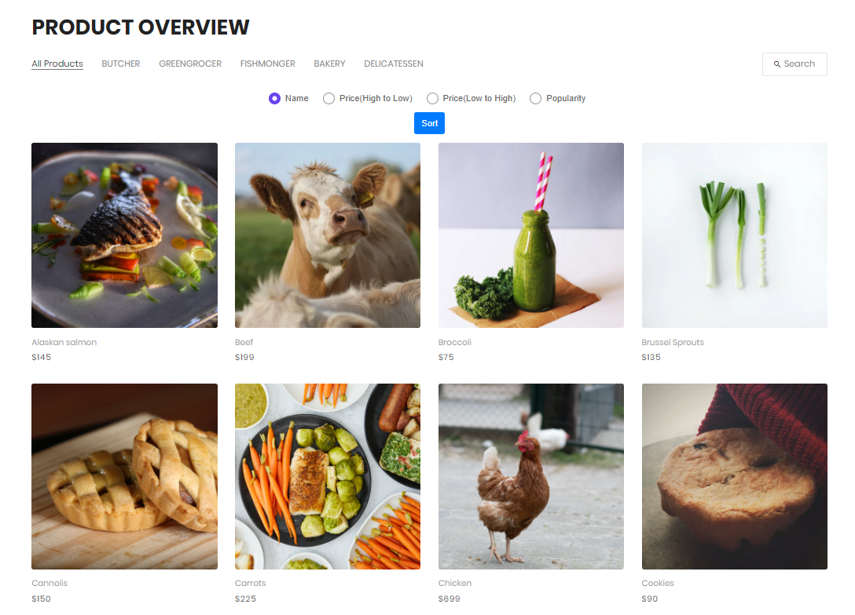

* If you want to view product details, then hover on the product then click on quick view. Then you will be redirected to product details page where you can see about the product details.

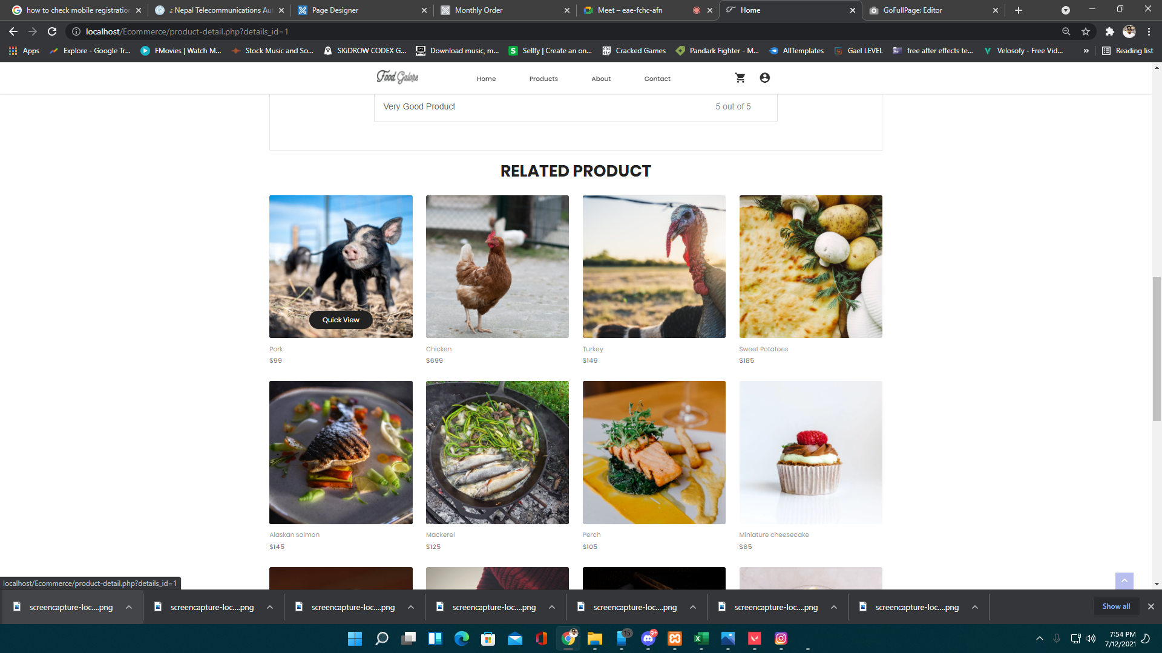

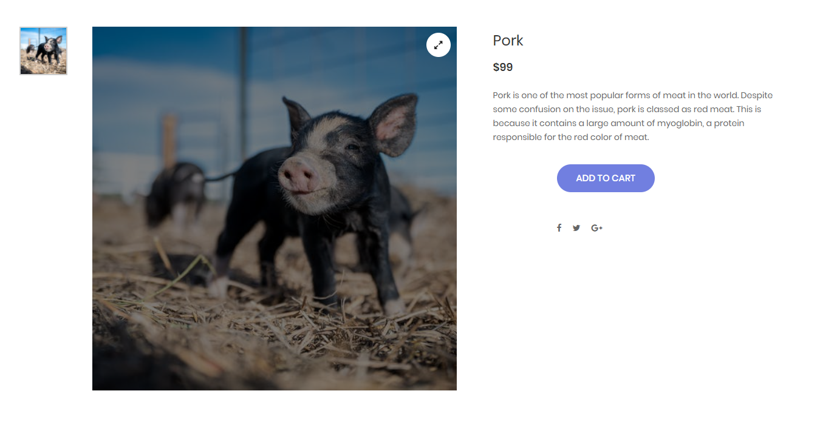

* If you want to add products to the cart then click on ‘ADD TO CART’ button. The products will be added on the cart. You can see the products in your cart by clicking cart icon that is on the navigation bar.

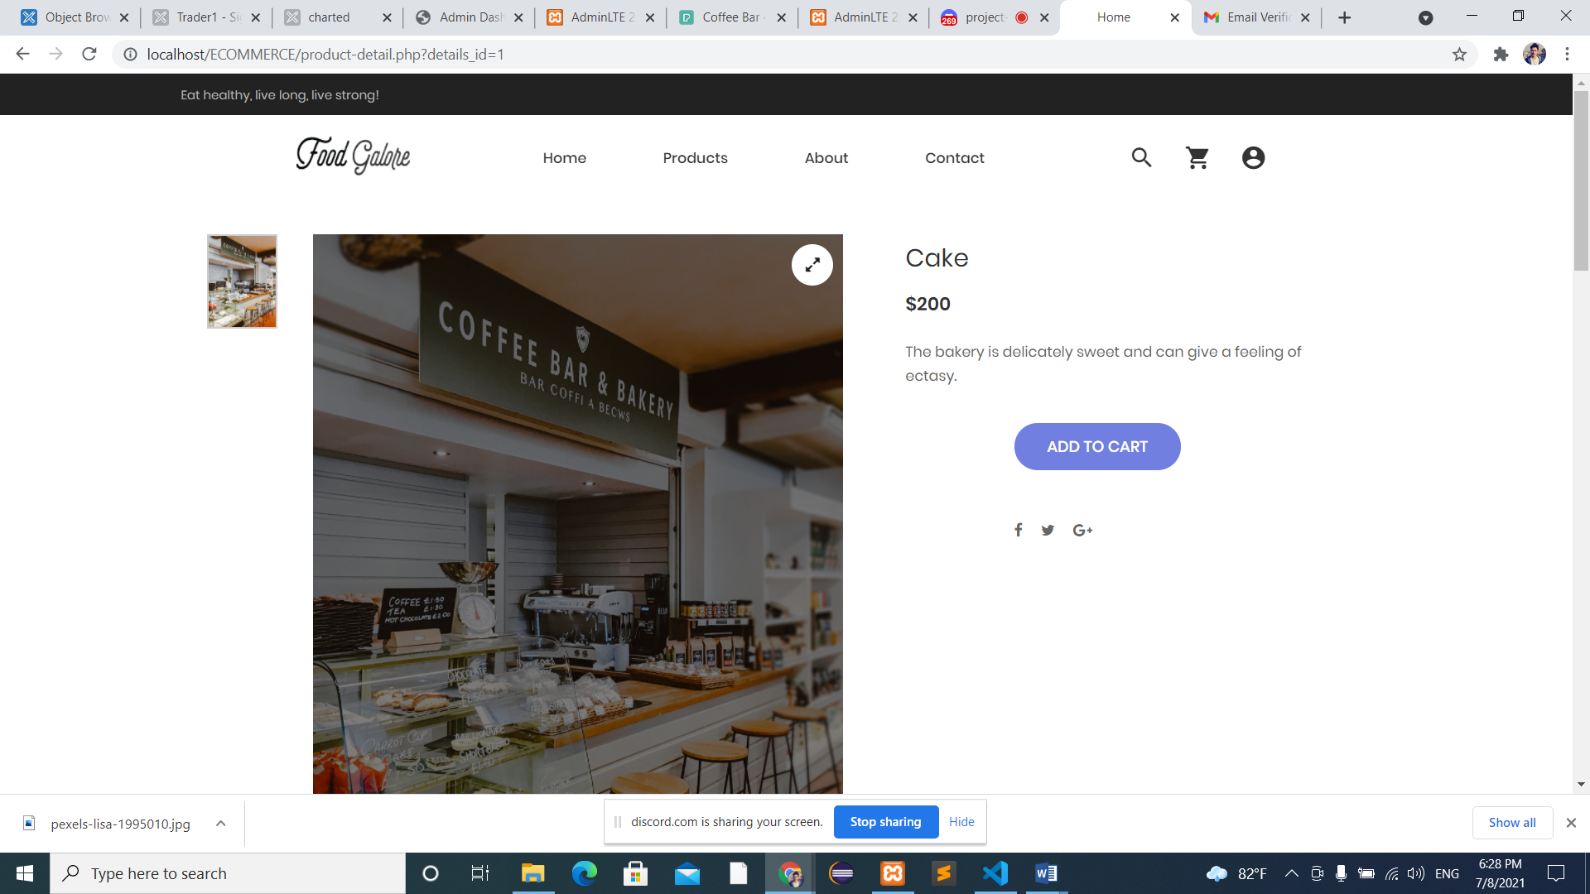

* You can see the products in your cart. If you wish to buy more quantity then you can add products and then click on update button. If you want to remove products then click on remove button and to remove all products click on remove all button. You can also see your totals on the right side including tax and discount. Select collection slot and collection day and then proceed to pay from PayPal. After clicking on PayPal you will be redirected to PayPal sign in page.

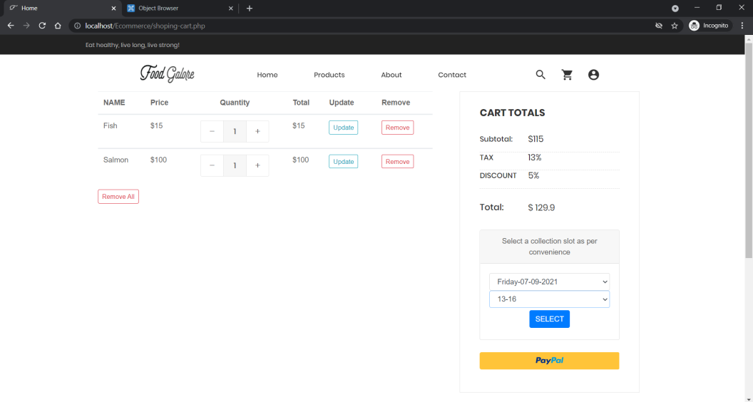

* Log in into your PayPal with your email and password. Then pay with your account.

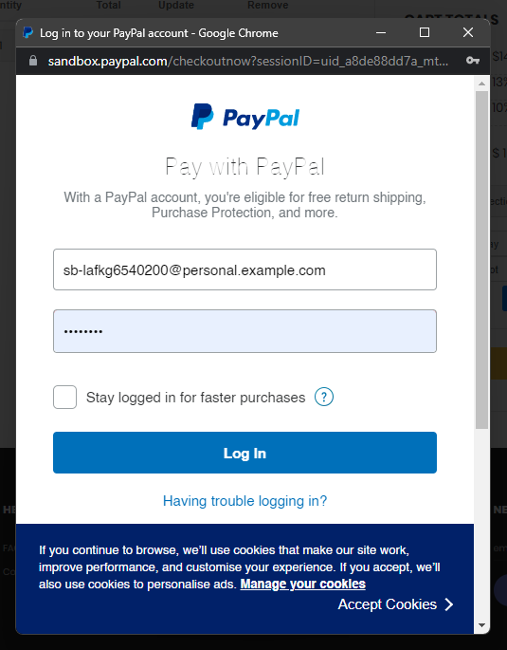

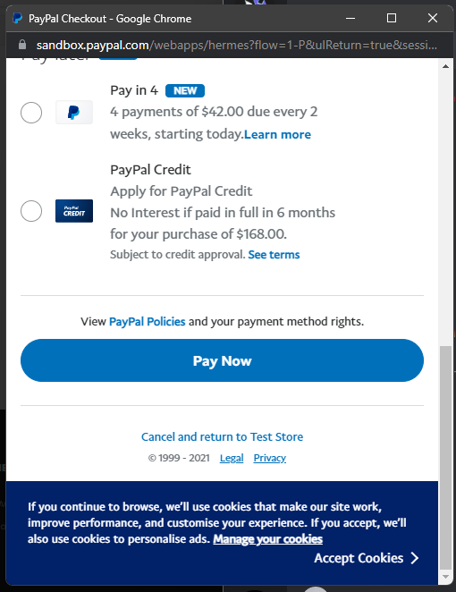\

* After paying the payment success message will be shown. If you wish to shop more click on shop more button.

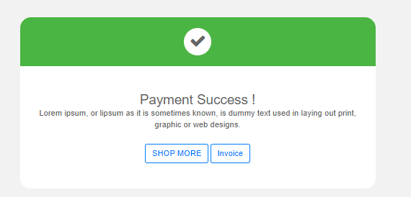

* To view your invoice click on invoice button then you will get your invoice and if you wish to print it click on print invoice button.

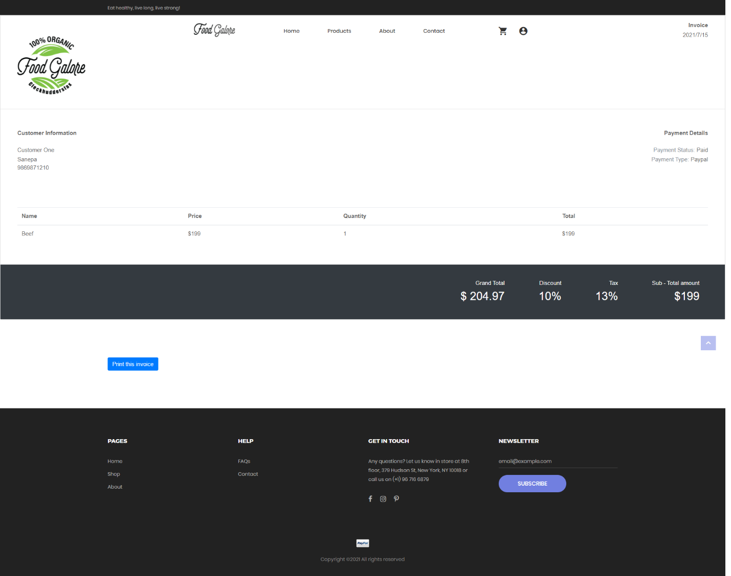

* You can see related products as well.

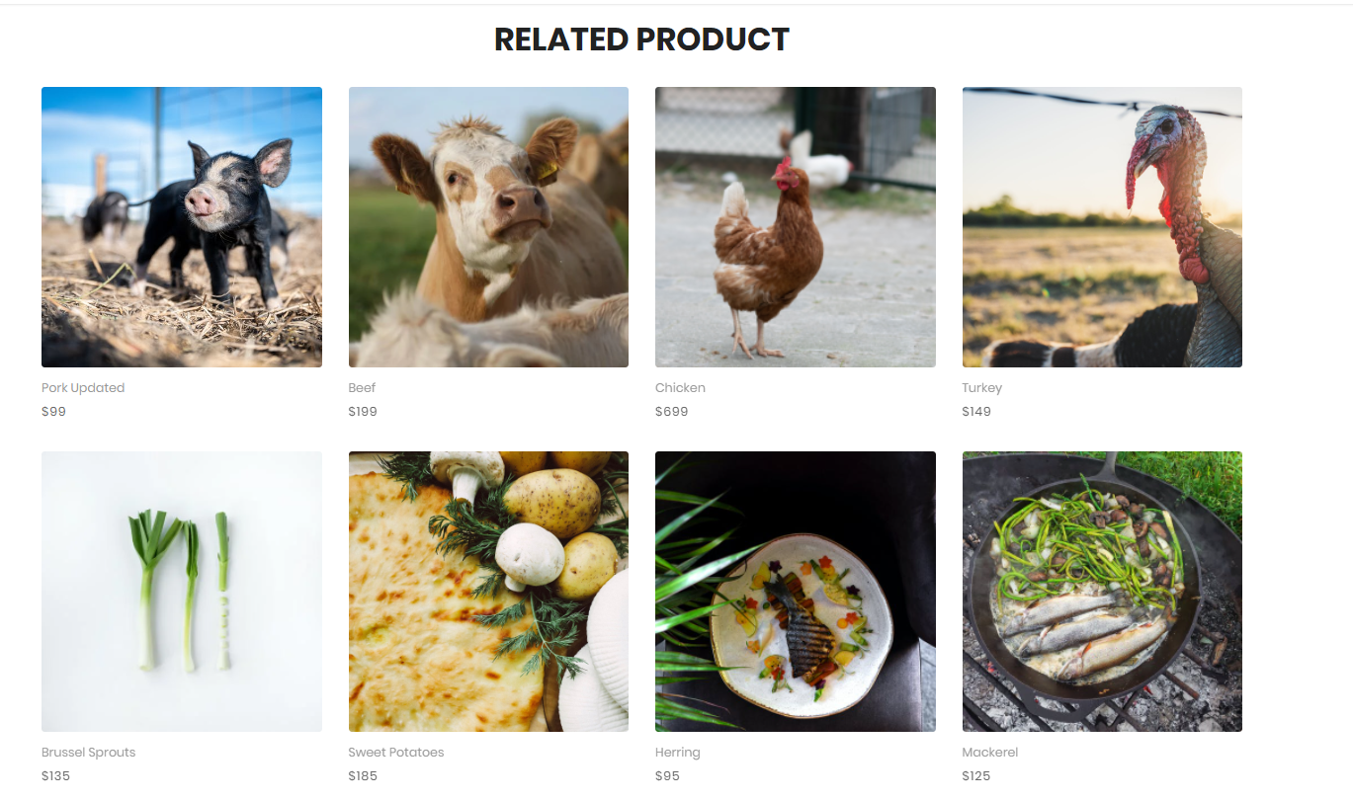

* You can look at the Frequently Asked Question by clicking on FAQs from the footer.

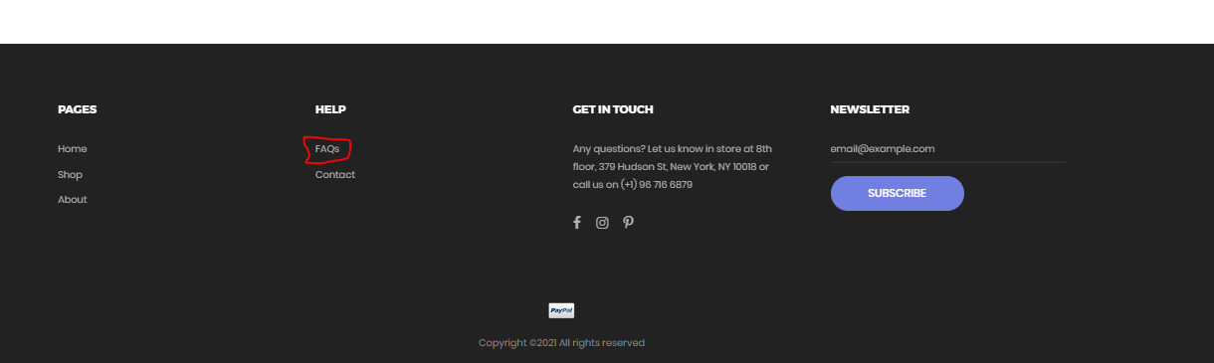

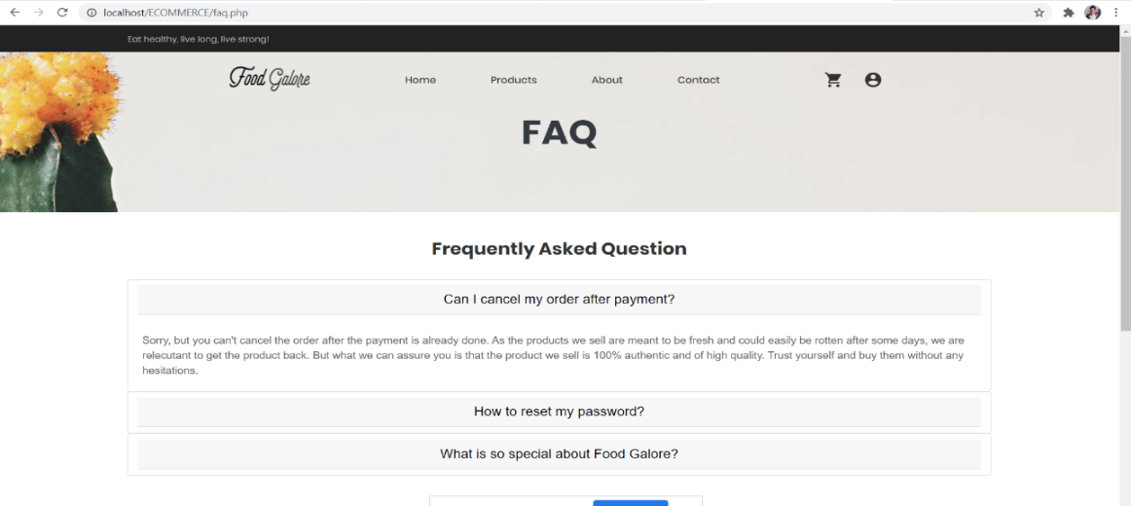

* You can also rate and review products.

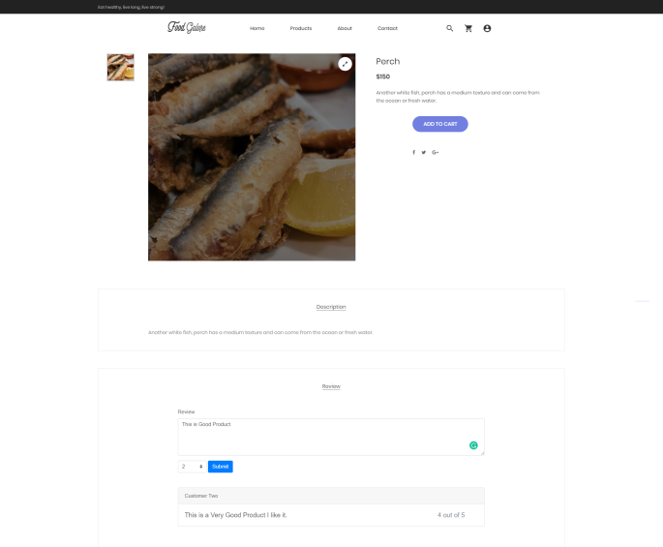

* If you click on your username in navigation bar then you can see three options. If you click on the first option then it’ll redirect you to your Dashboard. 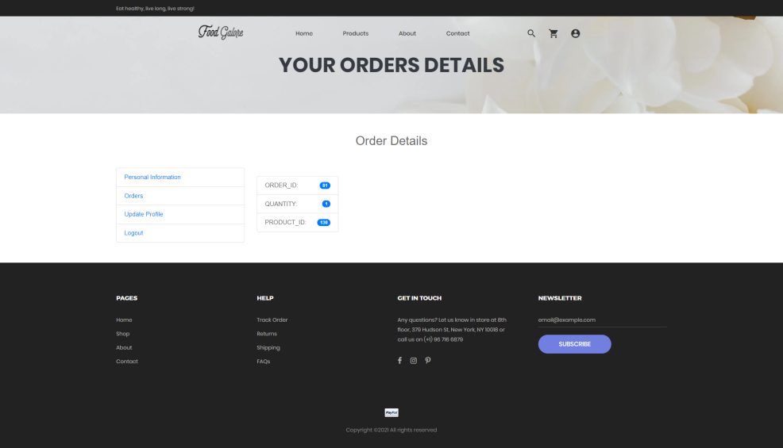
* When you are in your Dashboard page, you can edit your personal info and also view your order detail.

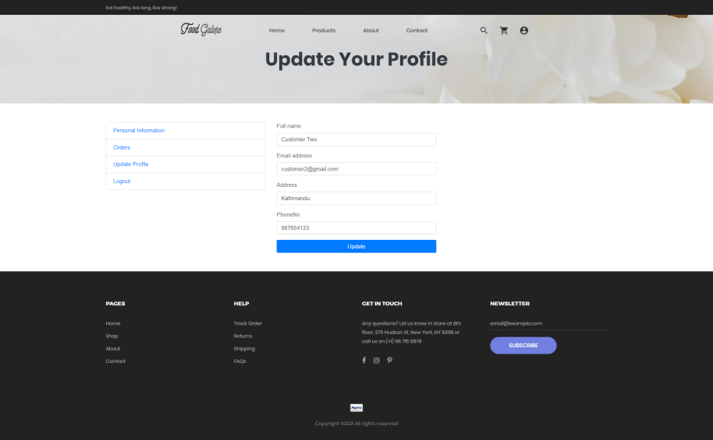

* You can send feedbacks or suggestions from contact us page.

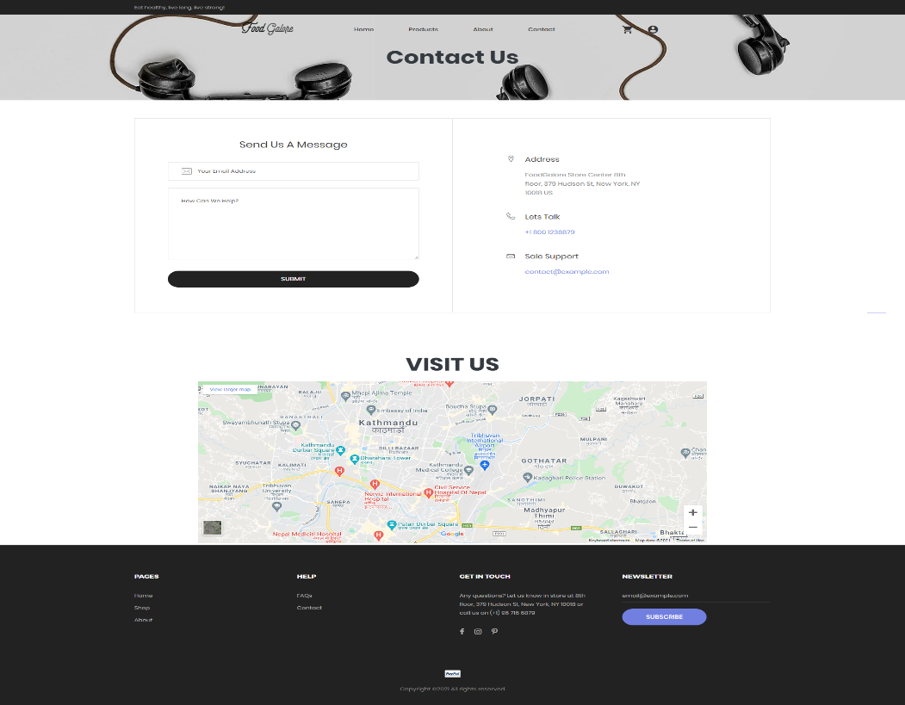

* If you want to logout of your account then you can click on your profile and then click on logout.

